**50.012 Networks Project**

**Cohort 2 Group 1 (H to O)**

Final Version

This will require the use of mininet.

1. From the Code folder, run setup.py. Once mininet is set up, execute “xterm cu pt ic”

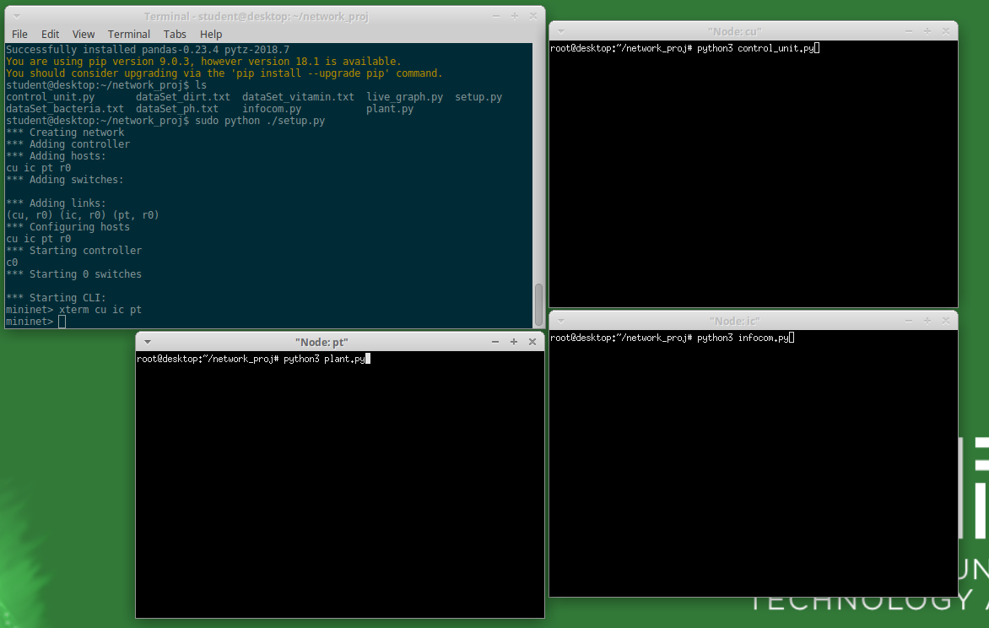

1. Once the three windows are set, type and run the following commands in sequence below
2. In pt, run 🡪 python3 plant.py
3. In cu, run 🡪 python3 control_unit.py
4. In ic, run 🡪 infocom.py

Ensure the connections are established.

1. In Node:cu, make yourself a user of the control_unit. Admin password when prompted is pw.

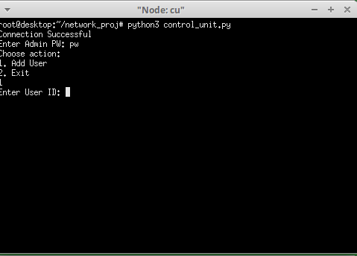

Once “User is successfully added”, exit the admin mode, and it will take you to the 10 commands you may do now that you are an established user. Type any of the given numbers and you can see its effect concurrently in all 3 nodes.

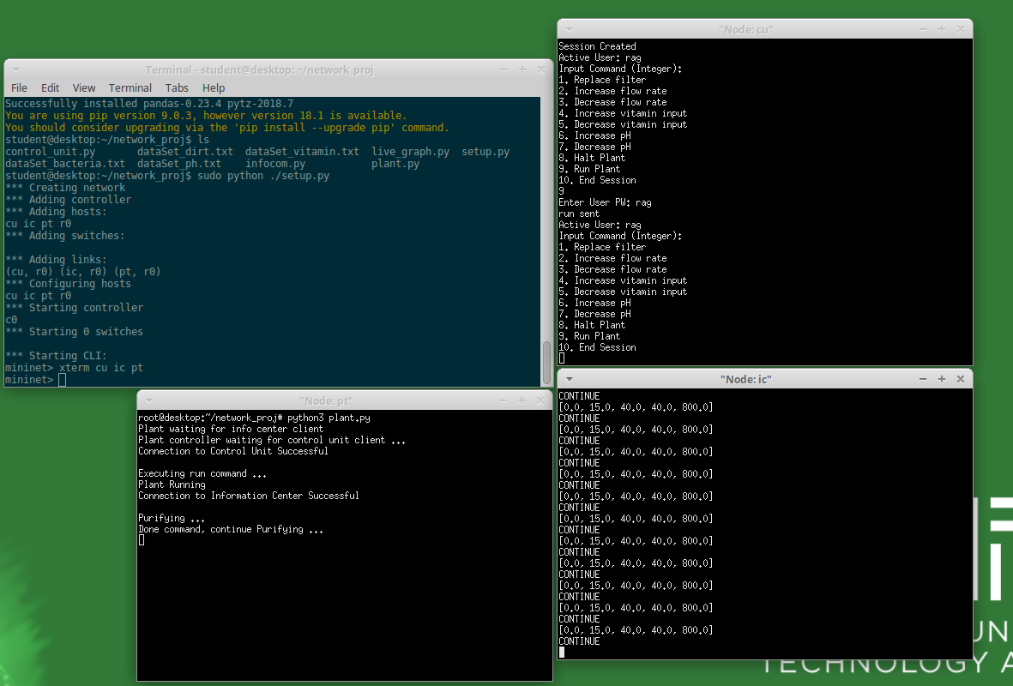

1. Lastly, to see the realtime graph of the processing, go back to the terminal and run xterm ic once more. Type “python3 live_graph.py”

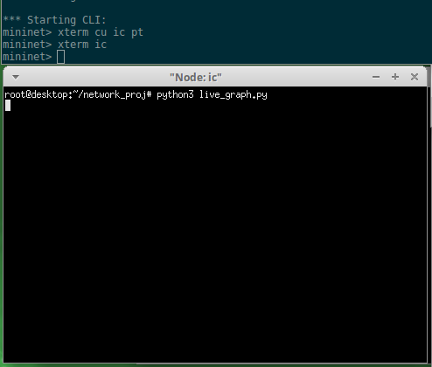

You will see 4 graphs indicating Vitamin, Bacteria, Dirt and pH levels.

*Note: ensure these packages have been sudo pip installed: matplotlib, pandas, xlwt